Updating Registration Deadlines

* Look* for “Registration Deadline Table”
* Each row in the table is defined by the <tr></tr> tag
* Headers are within <th></th> tag
* Cell content is within <td></td> tag
* Cross check with browser view to ensure the right cell is updated

Changing a link on the website

* In your text editor search* for the link that you want to change
* Replace it with the new link **between the quotations** (the blue text)
  + Note: If the quotes are missing, the link will be broken

Example:

<a href=”<https://www.artsci.utoronto.ca/faculty-staff/teacher-info/academic-handbook-for-instructors>” target="_blank">Academic Handbook for Instructors: Section 13-Accessibility/Disability Issues</a>

* The purple text is what displays on the website
* target="_blank" allows the link to open to a new page

Updating Gallery Photos

* Go to the folder “ATS/Imgaes/Gallery_images”
* Take a note of the **name** of the existing image to be replaced
* **Replace** this image with the new image with the **same name**
* **Note:** if the **name** of the **new image** does not match the **name of the old image**, the website will show NO image

Updating Accordion Content

A template can be found in the file info_for_staff.html under “Accordion Panel Template”

* Accordions are wrapped in the <dl></dl> tag
* Header
  + Each header of a panel (display when collapsed) is wrapped in <dt></dt> tag
  + The header title is wrapped in some header tag for eg. <h2>,<h3>, <h4> depending on the page
* Panel Content
  + Each panel is wrapped in a <dd></dd> tag
  + Content is styled within paragraph tags (<p>) or in list tags (<ul> or <ol>)
* IMPORTANT: increment ALL the numbers present in code by 1 in such that order is maintained otherwise the accordion will not function

**HTML Shortcuts**

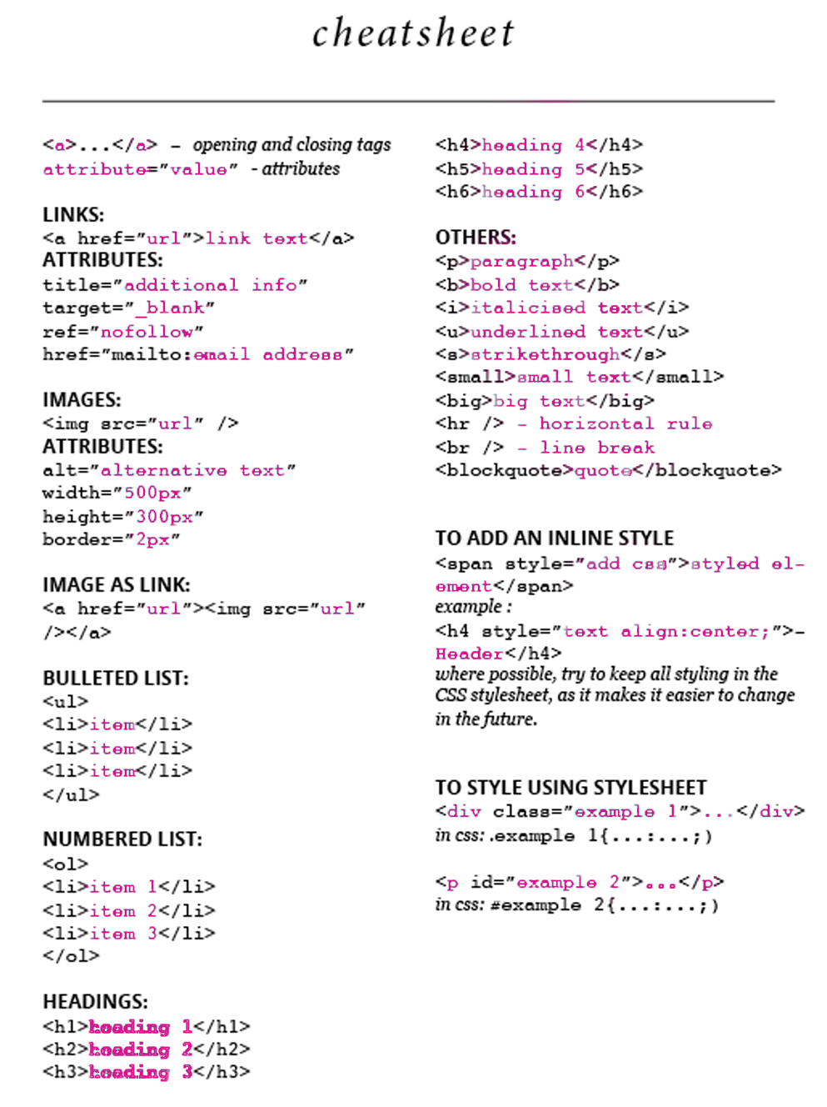*In your text editor **press ctrl + shift + f** to look up a word in the html document.